MILESTONE 3

1. Milestone Overview
Milestone 3 is titled “Transform Data & Validate And Enable Coalesce to Avoid Duplicate Records”. It covers Transform Data & Validate, Enable Coalesce to Avoid Duplicate Records, and Inserting New Data in Excel Format.
Milestone Detail | Value
Milestone | Milestone 3: Transform Data & Validate And Enable Coalesce to Avoid Duplicate Records
Project | Import Data using Transform Maps (Spreadsheet)
Complexity | Medium
Duration | 10h 0m
Activities | Transform Data & Validate; Enable Coalesce to Avoid Duplicate Records; Inserting New Data in Excel Format

2. Transform Data
The Transform Data process transfers employee information from the Import Set Table to the target Employee table using the Transform Map. It maps and converts fields such as Employee ID, Name, Email, Department, and Location and ensures that the imported data is stored correctly in the target table.

3. Validate Data
The Validate Data process checks the imported employee information before it is added to the target table. It ensures that required fields such as Employee ID, Name, and Email contain valid data and helps identify incorrect or incomplete records so they can be corrected.

4. Transform Data and Validate – Procedure
1. Open the Employee Test table from the Application Navigator.
2. Verify that the imported records are available in the Employee Test table.
3. Review the employee fields and confirm that the imported values are stored correctly.
4. Use the list configuration/personalize-list option when required to arrange the displayed fields.
5. Click OK after arranging the fields.
6. Confirm the final result in the Employee Test table.
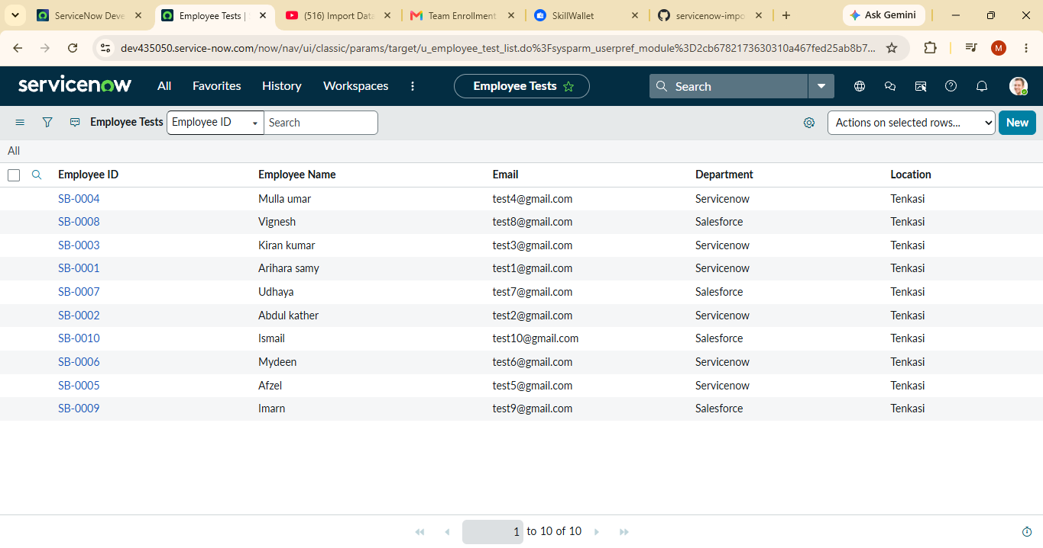
Figure 1: Employee Test table and imported records
The project instructions state that the import is successful when the records are created in the Employee Test table.

5. Enable Coalesce to Avoid Duplicate Records
Coalesce is used to identify existing employee records based on a unique field such as Employee ID. If the Employee ID already exists, the existing record is updated instead of creating a duplicate. If the Employee ID does not exist, ServiceNow creates a new employee record.

5.1 Procedure
1. Open Transform Map under User Import Sets from the All menus.
2. Open the created Transform Map named Sample Spreadsheet Import.
3. Under Related list, open the Field Maps section and make the required field Coalesce true where it is false.
4. Save the Transform Map.
5. Add new data to the Excel file and use it for the import process.
6. Open the created Transform Map again.
7. Go to Field Mapping.
8. Go to the unique field mapping and set the Coalesce value to true for the unique field.

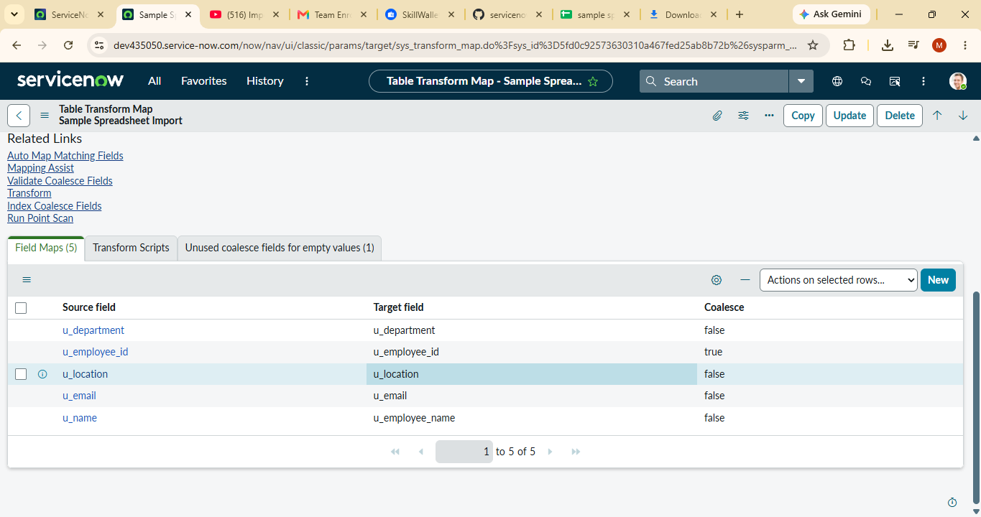
Figure 2: Transform Map and Field Mapping / Coalesce configuration

5.2 Coalesce Behaviour
Employee ID | Condition | Result
Existing ID | Employee ID already exists | Existing employee record is updated
New ID | Employee ID does not exist | New employee record is inserted

6. Inserting New Data in Excel Format
The milestone tests the coalesce configuration by adding new Excel data. The supplied instructions describe a test in which four rows are uploaded. Two rows use existing Employee IDs with changed Name and Email values, while two other rows contain new Employee IDs.

6.1 New Data Test
1. Prepare the new Excel data using the same structure as the existing employee data.
2. Use four rows of data for the test.
3. Change the Raviteja Employee Email from test10@gmail.com to test18@gmail.com.
4. Change the name associated with Employee ID SB-OOO4 from Ajay kumar to Ajay.
5. Add two other new Employee IDs.
6. Submit the import and confirm that the state becomes Completed and Success.
7. Click Run Transform under the next steps.
8. In Specify Import Set and Transform Map, use the previously selected Transform Map and click Transform.
9. Confirm that the transform state becomes Completed and Success.
10. Open Transform History to inspect the Inserted and Skipped/updated results.

6.2 Test Result
Rows Uploaded | Result | Reason
4 | 2 inserted | Two new Employee IDs
4 | 2 updated | Two existing Employee IDs with changed Name and Email
The project instructions report that four rows were uploaded: two were inserted because they had new IDs, and two were updated because they used the same IDs with changed Name and Email values. The Employee Test table was then opened to verify the updated and inserted records.
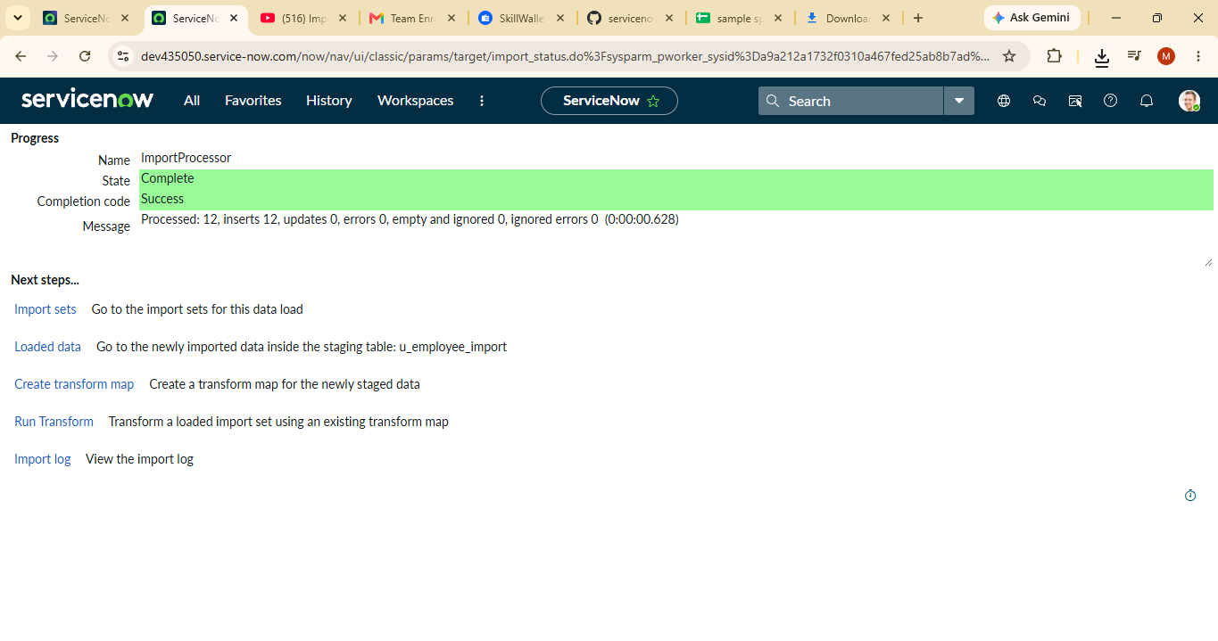

Figure 3: Transform history and validation of the imported data

7. Repeat Import with the Same Excel Sheet
The same import steps are repeated using the same Excel sheet to check whether the same records are inserted or updated again after coalesce is enabled.
1. Repeat the import process using the same Excel sheet.
2. Submit the import.
3. Open Transform History.
4. Review the number of uploaded, inserted, updated, and ignored rows.

7.1 Repeated Import Result
Result | Count
Rows uploaded | 4
Rows inserted | 0
Rows updated | 0
Rows ignored | 4
When the same four-row Excel sheet is submitted again, all four rows are ignored, with zero inserted and zero updated.

8. Milestone 3 Workflow
Import Set Data → Transform Data → Validate Employee Records → Enable Coalesce on Employee ID → Import New Excel Data → Run Transform → Check Transform History → Verify Employee Test Table

9. Completion Checklist
☐ Employee Test table opened and imported records verified.
☐ Imported employee information validated.
☐ Sample Spreadsheet Import Transform Map reviewed.
☐ Field Mapping section reviewed.
☐ Coalesce enabled for the unique Employee ID field.
☐ New Excel data prepared and submitted.
☐ Import state verified as Completed and Success.
☐ Run Transform executed and verified as Completed and Success.
☐ Transform History checked.
☐ Four-row test verified: 2 inserted and 2 updated.
☐ Same four-row file repeated: 0 inserted, 0 updated, 4 ignored.

10. Conclusion
Milestone 3 completes the main data transformation and duplicate-handling test. The imported employee data is transformed and validated in the Employee Test table. Coalesce uses Employee ID to distinguish existing and new records. In the four-row test, two existing records were updated and two new records were inserted. When the same file was imported again, all four rows were ignored, with no new inserts or updates.

